Smart Triage &
Resource Allocation System
(STRA-System)
Comprehensive Requirements
&
System Design Document

Table of Contents
1. Executive Summary 4
2. Detailed Requirements Specification 4
2.1 Functional Requirements 4
FR-001: Patient Registration & Triage Module 4
FR-002: Triage Algorithm & Classification 4
FR-003: Real-time Queue Management 5
FR-004: Resource Allocation Dashboard 5
FR-005: Medicine & Inventory Management 5
FR-006: Doctor Portal 5
FR-007: Analytics & Reporting 6
FR-008: Notifications & Alerts 6
FR-009: Security & Access Control 6
3. System Architecture & Flow Design 7
3.1 High-Level System Architecture 7
3.2 Core Workflow Diagrams 9
3.2.1 Patient Triage & Routing Flow 9
3.2.2 Resource Allocation Decision Flow 11
3.3 Data Flow Design 11
Data Flow 1: Triage Data Processing 11
Data Flow 2: Resource Monitoring 11
4. Database Schema Design 12
4.1 Core Tables 12
5. API Specification 16
5.1 Key Endpoints 16
6. Non-Functional Requirements 17
6.1 Performance Requirements 17
6.2 Availability Requirements 17
6.3 Security Requirements 17
6.4 Scalability Requirements 17
7. Implementation Roadmap 18
Phase 1: Foundation (Weeks 1-4) 18
Phase 2: Resource Management (Weeks 5-8) 18
Phase 3: Advanced Features (Weeks 9-12) 18
Phase 4: Optimization & Deployment (Weeks 13-16) 18
8. Success Metrics & KPIs 19
Operational KPIs 19
Clinical KPIs 19
Financial KPIs 19
9. Risk Mitigation Strategy 20
10. Appendices 21
10.1 Triage Scoring Algorithm 21
10.2 Hardware Requirements 21

1. Executive Summary
A hospital-focused digital triage platform enabling efficient patient flow, real-time resource allocation, and data-driven decision-making for healthcare facilities in Kenya. The system digitizes manual triage processes, provides predictive analytics, and optimizes staff and resource deployment.

2. Detailed Requirements Specification

2.1 Functional Requirements

FR-001: Patient Registration & Triage Module
- FR-001.1: Nurses shall enter patient demographics (name, age, gender, contact)
- FR-001.2: System shall capture vital signs (BP, pulse, temperature, SpO₂, respiration rate)
- FR-001.3: Nurses shall document presenting symptoms via structured checklist
- FR-001.4: System shall calculate pain scale (1-10) with visual analog scale support
- FR-001.5: System shall automatically assign urgency level based on triage algorithm
- FR-001.6: System shall generate unique patient identifier (STRA-ID)
- FR-001.7: Offline data capture with automatic sync when connectivity restored

FR-002: Triage Algorithm & Classification
- FR-002.1: Implement Modified Early Warning Score (MEWS) calculation
- FR-002.2: Assign triage categories:
- RED (Critical): Immediate medical attention (<10 minutes)
- YELLOW (Urgent): Medical attention within 30 minutes
- GREEN (Non-urgent): Medical attention within 2 hours
- FR-002.3: Recommend department allocation based on symptoms + vitals
- FR-002.4: Calculate estimated wait time based on queue length and urgency

FR-003: Real-time Queue Management
- FR-003.1: Dynamic patient queue per department
- FR-003.2: Priority-based queue jumping for critical cases
- FR-003.3: Real-time queue status display in waiting areas
- FR-003.4: Automated notifications when patient reaches front of queue

FR-004: Resource Allocation Dashboard
- FR-004.1: Real-time patient load per department visualization
- FR-004.2: Staff availability tracking (doctors, nurses, technicians)
- FR-004.3: Bed occupancy monitoring with bed status (available/occupied/cleaning)
- FR-004.4: Equipment utilization tracking (ventilators, monitors, etc.)
- FR-004.5: Predictive load forecasting for next 4, 8, 12 hours

FR-005: Medicine & Inventory Management
- FR-005.1: Track medication usage against triage diagnoses
- FR-005.2: Automatic stock level updates when prescriptions filled
- FR-005.3: Low stock alerts with reorder recommendations
- FR-005.4: Consumption trend analysis by department/season

FR-006: Doctor Portal
- FR-006.1: View assigned patient queue with triage details
- FR-006.2: Access complete patient vitals and history
- FR-006.3: Order diagnostics (labs, imaging) electronically
- FR-006.4: Prescription module with drug interaction checks
- FR-006.5: Disposition tracking (admit/discharge/transfer)

FR-007: Analytics & Reporting
- FR-007.1: Daily/Weekly/Monthly patient volume reports
- FR-007.2: Average wait time by department and urgency
- FR-007.3: Disease outbreak detection algorithms
- FR-007.4: Staff productivity and utilization metrics
- FR-007.5: Resource utilization efficiency reports

FR-008: Notifications & Alerts
- FR-008.1: SMS alerts for critical patients (RED category)
- FR-008.2: Department overload alerts to management
- FR-008.3: Stock shortage notifications to pharmacy
- FR-008.4: Shift change summaries to incoming staff

FR-009: Security & Access Control
- FR-009.1: Role-based access control (RBAC) with 5+ permission levels
- FR-009.2: Patient data encryption at rest and in transit
- FR-009.3: Audit trail for all patient data access
- FR-009.4: Session management with auto-logout

3. System Architecture & Flow Design

3.1 High-Level System Architecture

Presentation Layer
Nurse  portal | Doctor  Portal | Admin  Portal | Pharmacy  Dashboard
React | React | React | React

API Gateway Layer
- Authentication & Authorization
- Rate Limiting
- Request Routing
Laravel Framework

Microservices Layer
Triage  Service | Queue  Service | Resource  Service | Analytics  Service
Laravel  Framework | Laravel  Framework | Laravel  Framework | Laravel  Framework

Data Layer
PostgreSQL | Laravel | Resource  Service | Backup
Primary RDBMS | Cache /  Queue | GC  Data lake | System  3-2-1

3.2 Core Workflow Diagrams

3.2.1 Patient Triage & Routing Flow
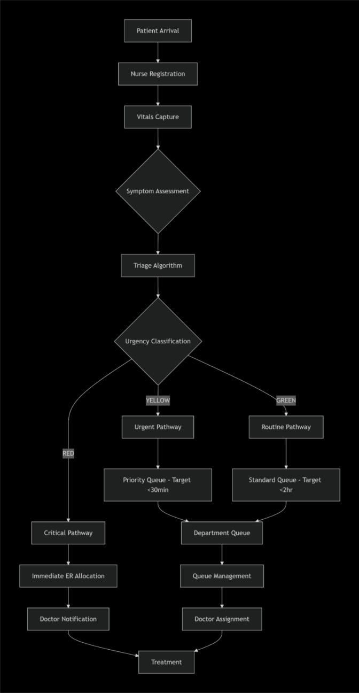

3.2.2 Resource Allocation Decision Flow

3.3 Data Flow Design

Data Flow 1: Triage Data Processing

Nurse Input → Validation → Triage Scoring → Classification → Queue Assignment → Database Storage → Real-time Updates

Data Flow 2: Resource Monitoring

Sensor/Manual Input → Data Aggregation → Threshold Check → Alert Generation → Dashboard Update → Notification Dispatch

4. Database Schema Design

4.1 Core Tables
sql
Patients Table
CREATE TABLE patients (
patient_id UUID PRIMARY KEY,
stra_id VARCHAR(20) UNIQUE,
first_name VARCHAR(100),
last_name VARCHAR(100),
date_of_birth DATE,
gender VARCHAR(10),
phone_number VARCHAR(15),
emergency_contact VARCHAR(15),
created_at TIMESTAMP DEFAULT NOW(),
updated_at TIMESTAMP
);

Triage Sessions Table
CREATE TABLE triage_sessions (
session_id UUID PRIMARY KEY,
patient_id UUID REFERENCES patients(patient_id),
nurse_id UUID REFERENCES users(user_id),
temperature DECIMAL(4,2),
systolic_bp INTEGER,
diastolic_bp INTEGER,
heart_rate INTEGER,
respiratory_rate INTEGER,
oxygen_saturation DECIMAL(4,2),
pain_scale INTEGER CHECK (pain_scale BETWEEN 1 AND 10),
symptoms JSONB,
triage_score INTEGER,
urgency_level VARCHAR(10), -- RED/YELLOW/GREEN
recommended_dept VARCHAR(50),
estimated_wait_minutes INTEGER,
created_at TIMESTAMP DEFAULT NOW()
);

-- Department Queues Table
CREATE TABLE department_queues (
queue_id UUID PRIMARY KEY,
department_id UUID REFERENCES departments(department_id),
patient_id UUID REFERENCES patients(patient_id),
urgency_level VARCHAR(10),
position_in_queue INTEGER,
expected_wait_time INTEGER,
status VARCHAR(20), -- WAITING, IN_PROGRESS, COMPLETED
created_at TIMESTAMP DEFAULT NOW(),
updated_at TIMESTAMP
);

-- Resource Inventory Table
CREATE TABLE resources (
resource_id UUID PRIMARY KEY,
resource_type VARCHAR(50), -- BED, VENTILATOR, MONITOR
department_id UUID REFERENCES departments(department_id),
status VARCHAR(20), -- AVAILABLE, OCCUPIED, MAINTENANCE
last_maintenance DATE,
created_at TIMESTAMP DEFAULT NOW()
);

-- Medication Stock Table
CREATE TABLE medication_stock (
medication_id UUID PRIMARY KEY,
medication_name VARCHAR(200),
generic_name VARCHAR(200),
current_stock INTEGER,
minimum_threshold INTEGER,
reorder_quantity INTEGER,
unit_cost DECIMAL(10,2),
last_restock_date DATE,
supplier_id UUID REFERENCES suppliers(supplier_id)
);

5. API Specification

5.1 Key Endpoints
Triage Module
- POST /api/v1/triage/register - Register new patient
- POST /api/v1/triage/vitals - Record patient vitals
- POST /api/v1/triage/calculate - Calculate triage score
- GET /api/v1/triage/queue/{deptId} - Get department queue
Resource Management
- GET /api/v1/resources/dashboard - Get resource dashboard
- GET /api/v1/resources/staff-availability - Get staff availability
- POST /api/v1/resources/allocate - Allocate resource
- GET /api/v1/resources/predictive-load - Get predictive analytics
Doctor Portal
- GET /api/v1/doctor/queue - Get doctor's patient queue
- GET /api/v1/doctor/patient/{id} - Get patient details
- POST /api/v1/doctor/order-lab - Order lab tests
- POST /api/v1/doctor/prescription - Create prescription
Inventory Management
- GET /api/v1/inventory/medications - Get medication stock
- PUT /api/v1/inventory/{inventoryId}- Update stock levels
- GET /api/v1/inventory/alerts - Get low stock alerts

6. Non-Functional Requirements

6.1 Performance Requirements
- Triage data entry: < 60 seconds per patient
- System response time: < 2 seconds for 95% of requests
- Concurrent users support: Up to 100 simultaneous users
- Data sync latency: < 30 seconds when coming online

6.2 Availability Requirements
- Uptime: 99.5% during hospital operating hours
- Disaster Recovery: RPO < 1 hour, RTO < 4 hours
- Backup: Daily incremental, weekly full backups

6.3 Security Requirements
- HIPAA/Kenya Data Protection Act compliance
- End-to-end encryption for patient data
- Regular security audits and penetration testing
- Multi-factor authentication for admin users

6.4 Scalability Requirements
- Support for 500+ daily patient entries
- Scalable to multiple hospital branches
- Modular architecture for feature additions

7. Implementation Roadmap

Phase 1: Foundation (Weeks 1-4)
- Core patient registration and triage module
- Basic queue management system
- Nurse and doctor user authentication
- Local database with offline support

Phase 2: Resource Management (Weeks 5-8)
- Real-time dashboard development
- Staff allocation module
- Bed and equipment tracking
- Basic reporting system

Phase 3: Advanced Features (Weeks 9-12)
- Predictive analytics engine
- Medication tracking system
- Advanced reporting and analytics
- Integration with SMS alerts

Phase 4: Optimization & Deployment (Weeks 13-16)
- Performance optimization
- User acceptance testing
- Staff training materials
- Production deployment

8. Success Metrics & KPIs

Operational KPIs
- Average triage time: Target < 4 minutes
- Critical patient wait time: Target < 10 minutes
- Patient satisfaction score: Target > 85%
- Resource utilization rate: Target 70-85%

Clinical KPIs
- Time-to-treatment for critical cases
- Patient handoff efficiency
- Medication availability rate
- Diagnostic turnaround time

Financial KPIs
- Reduction in overtime costs
- Decrease in medication waste
- Improved bed turnover rate
- Reduction in equipment idle time

9. Risk Mitigation Strategy
Risk | Probability | Impact | Mitigation  Strategy
Internet connectivity issues | High | High | Robust offline mode with automatic sync
Staff resistance to change | Medium | Medium | Comprehensive training and change management
Data privacy concerns | High | High | End-to-end encryption and compliance measures
System performance during peak | Medium | High | Load testing and scalable architecture
Integration with existing systems | Medium | Medium | API-first approach with flexible integration

10. Appendices

10.1 Triage Scoring Algorithm

MEWS Calculation:
- Respiration Rate: 12-20 = 0, 9-11 or 21-24 = 1, <9 or >24 = 2
- SpO₂: ≥96% = 0, 94-95% = 1, 92-93% = 2, <92% = 3
- Temperature: 36.1-38.0 = 0, 35.1-36.0 or 38.1-39.0 = 1, <35 or >39 = 2
- Systolic BP: 101-149 = 0, 81-100 or 150-199 = 1, <80 or >199 = 2
- Heart Rate: 51-100 = 0, 41-50 or 101-110 = 1, <40 or 111-129 = 2, >129 = 3

Total MEWS Score:
- 0-1: GREEN
- 2-3: YELLOW
- 4+: RED

10.2 Hardware Requirements
- Minimum: 8GB RAM, 4-core processor, 500GB storage
- Recommended: 16GB RAM, 8-core processor, 1TB SSD storage
- Network: Minimum 10Mbps dedicated connection

